# Lab 01: The Landing Before the Launch

Woodgrove Bank is a global bank that has been in business for over 100 years. They have a large customer base and are looking to expand their business by offering new services to their customers. Members have accounts, each account with corresponding balances, overdraft limits and credit/debit transactions. They are looking to build a new application that will allow their customers to manage their accounts and better understand their bank transactions that contribute to their overall balance. They have decided to use Azure Cosmos DB and Azure OpenAI Service to build these new capabilities.

Woodgrove Bank wants to ride the wave of conversational AI to allow customers to interact with their bank accounts using natural language. They want to build a chatbot that will allow customers to ask questions about their accounts and transactions. They also want to build a secure architecture that provides high availability and scalability to support their global customer base. They are interested in how they can use high consistency across multiple regions, allowing customers to read and write to database endpoints in their local region, and make sure that the data is consistent across all regions. A pattern they want to explore is to separate read and write operations since the transaction data has a high rate of volume. They do not want to impact the performance of their database operations by introducing heavy reads against the same resource handling incoming write operations. They also want to make sure that if a region goes down, their customers within the impacted region can still access their accounts and make transactions.

**Objective :**

* Run the script to deploy the services into the landing zone in preparation for the launch of the POC.

## **Task 0: Sync Host environment time**

1. In your VM, navigate and click in the **Search bar**, type **Settings** and then click on **Settings** under **Best match**.

1. On Settings window, navigate and click on **Time & language**.

1. On **Time & language** page, navigate and click on **Date & time**.

1. Scroll down and navigate to **Additional settings** section, then click on **Sync now** button.

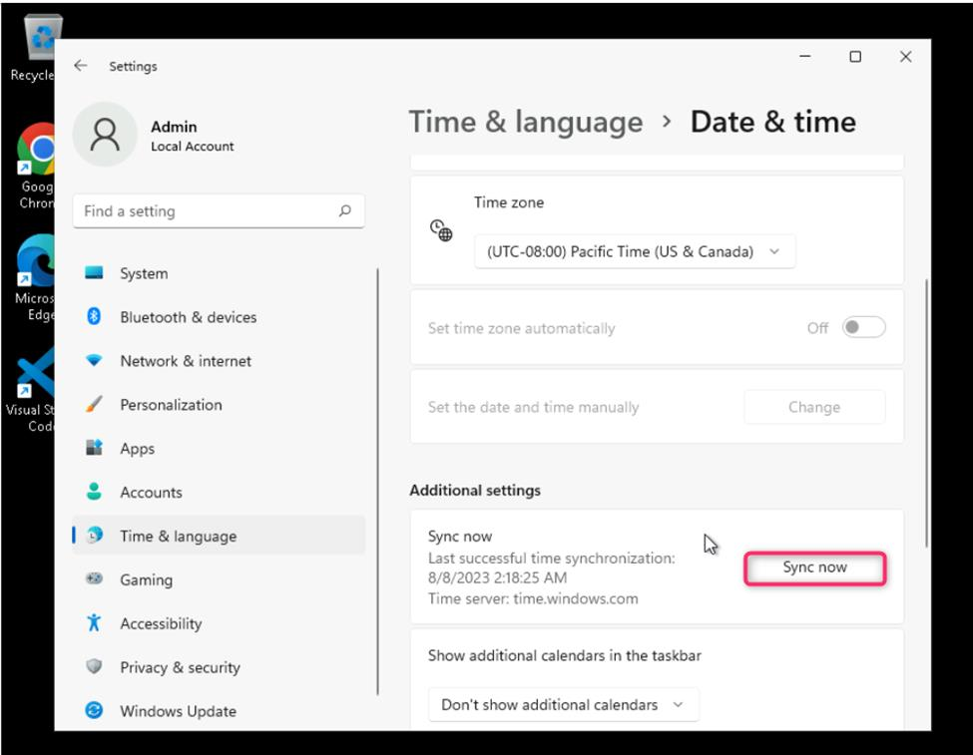

1. Close the **Settings** window.

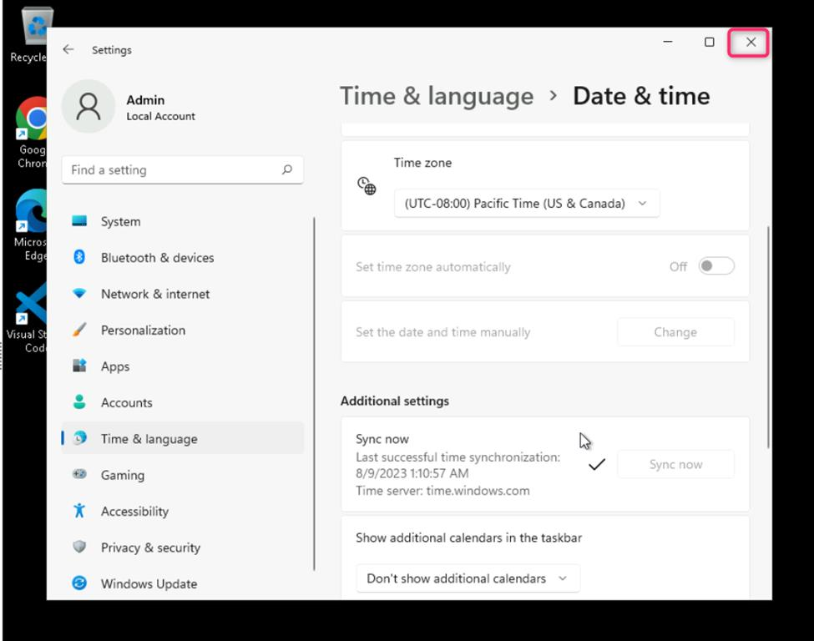

## **Task 1: Install nvm**

1. In Windows explorer go to **C:\Program Files\Software** and double click on nvm-setup(1).exe file.

1. In the **User Account Control** tab, click on **Yes** button.

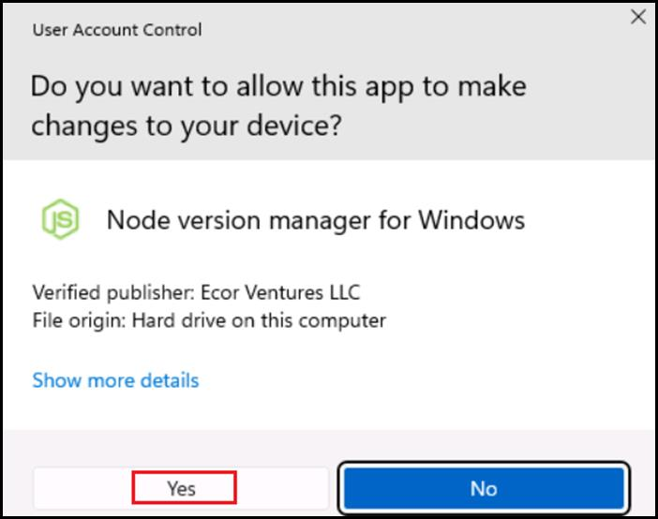

1. On the Setup-NVM for Windows tab select the **I accept the agreement** and click on **Next** button

1. Select the path and click on **Next** button.

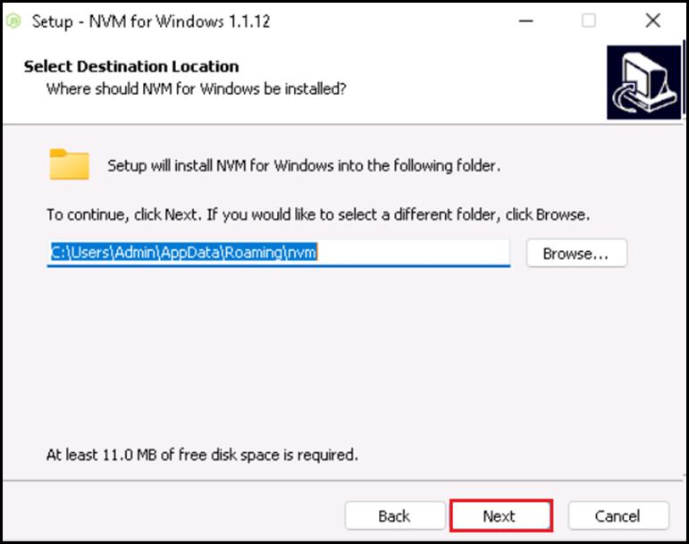

1. Click on **Next** in the **Set Node.js Symlink** dialog.

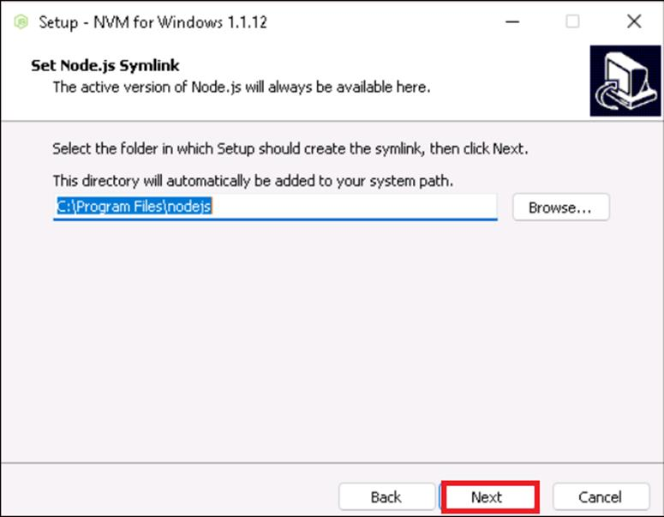

1. On Ready to install tab , click on **Install** button.

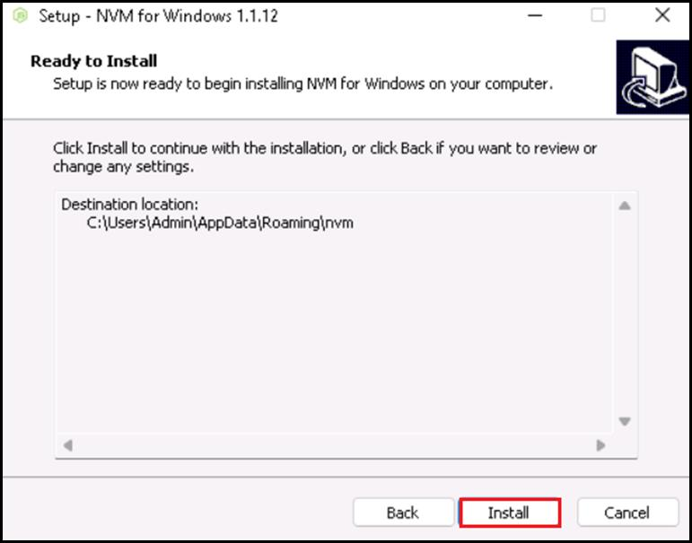

1. Click on **Ok**.

1. Click on the **Finish** button.

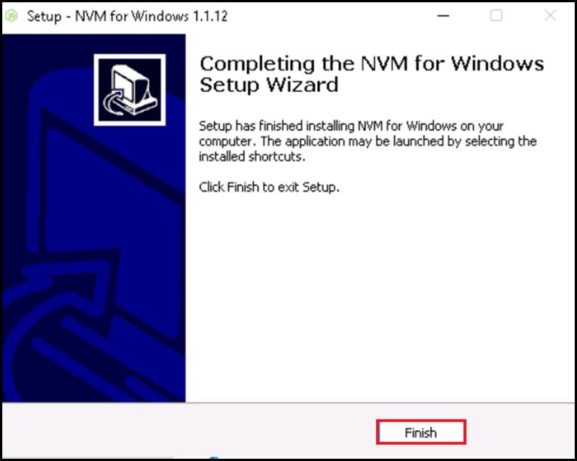

## **Task 2: Install Node.js**

1. In Windows explorer go to **C:\Program Files\Software** and double click on **node-v20.11.0-x64.msi** file

1. In the **Node.js Setup** tab, click on **Next** button.

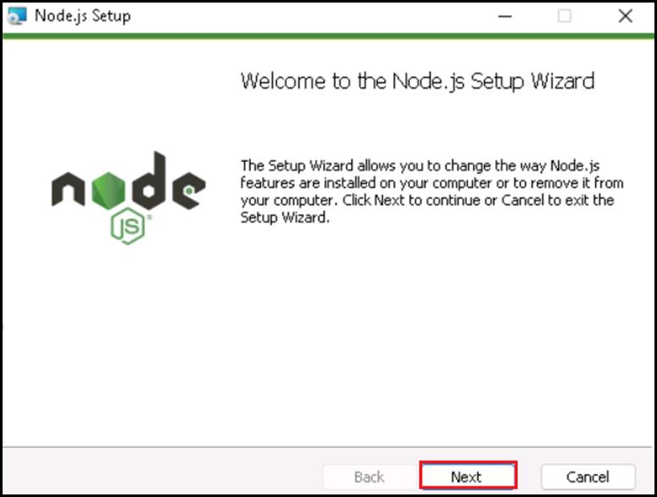

1. Click on **Repair** button.

1. In the User Account Control tab, click on **Yes** button.

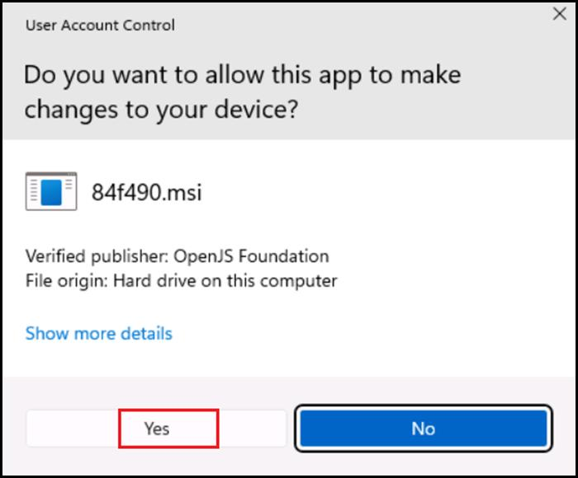

1. Click on **Finish**.

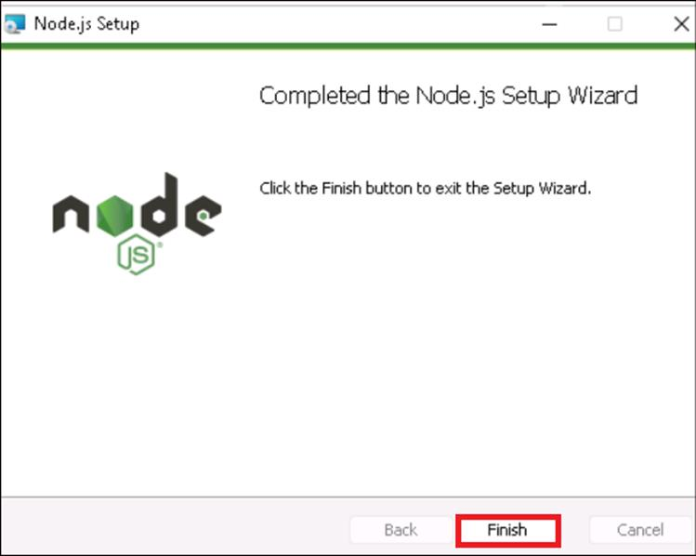

## **Task 3: Install Winget**

1. Open your browser, navigate to the address bar, type or paste the following URL: **https://learn.microsoft.com/en-us/windows/package-manager/winget/** then press the Enter button.
2. In Microsoft store, click on **Install** for the **App Installer**.

1. In the **An update is ready** dialog, click on **Install** button.

1. In the App Installer, click on **update** button.

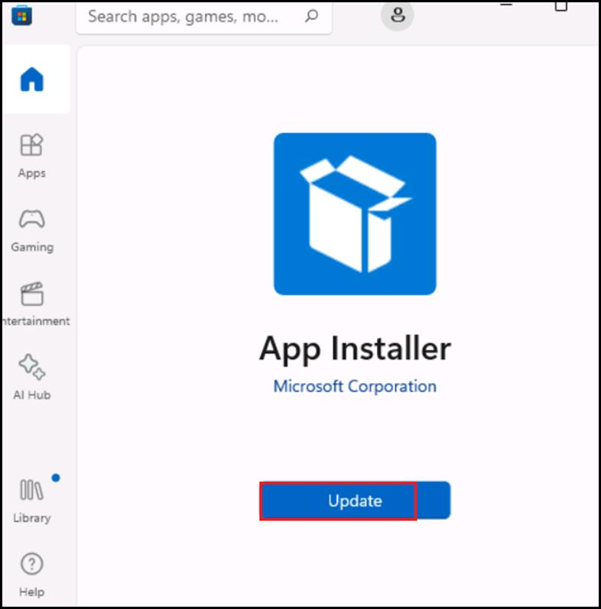

1. After finishing the updates, close the Microsoft app.

## **Task 4: Register the required Resource providers**

1. Open your browser, navigate to the address bar, type or paste the following URL: +++[**https://portal.azure.com/**](https://portal.azure.com/)**+++**, then press the **Enter** button.

1. Click on the **Resources** tab, Note down the **Username** and **Password** under the **User Credentials**. This will be your login credentials to login to Azure.

1. In the **Sign in** window, enter the **Username** and click on the **Next** button.

1. Then, enter the password and click on the **Sign in** button**.**

1. In **Stay signed in?** window, click on the **Yes** button.

1. On **Welcome to Microsoft Azure** dialog box, click on **Maybe later** button.

1. In the Azure portal search box, type +++**Subscriptions**+++, then click on **Subscriptions** under **Services**.

1. Copy the **Subscrption ID** from the Subscriptions page and store it in a notepad for usage in the next tasks.

1. In the **Subscriptions** page, click on **Azure Pass – Sponsorship**.

1. In the **Azure Pass – Sponsorship** page, navigate to the **Settings** section in the left navigation pane, and click on the **Resource Providers**.

1. In the **Azure Pass – Sponsorship | Resource providers** page, navigate to the search box and type +++**Microsoft.Storage**+++. Click on **Microsoft.Storage** under **Provider**. Then, in the **Resource Provider Details** pane that appears on the right side, select the latest **API Versions**, then click on the **Register** as shown in the below image.

1. You’ll see a notification stating - **Successfully registered resource provider** once the registration is successful. You can also view the notification by clicking on the bell icon in the Azure portal.

1. In the **Azure Pass – Sponsorship | Resource providers** page, navigate to the search box and type ++**Microsoft.OperationsManagement**++. Click on M**icrosoft.OperationsManagement** under **Provider**. Then, in the **Resource Provider Details** pane that appears on the right side, select the latest **API Versions**, then click on the **Register** as shown in the below image.

1. You’ll see a notification stating - **Successfully registered resource provider** once the registration is successful. You can also view the notification by clicking on the bell icon in the Azure portal.

## **Task 5: Create resource group**

1. In the Azure portal search box, type +++**resource group**+++, click on **Resource group** under **Services**.

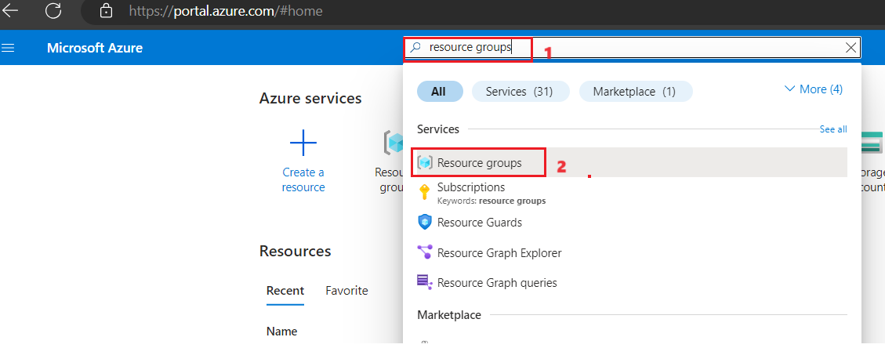

1. Click on **+ Create** to create a new Resource group.

1. In the **Create Resource group** window, under the **Basics** tab, enter the following details and click on the **Review+create** button.

|  |  |
| --- | --- |
| **Subscription** | Select the assigned subscription |
| **Resource group** | Enter +++**AOAI-work_RGXX+++** (XX can be a unique number, you can add more digits after XX to make the name unique) |
| **Region** | Select **East US** |

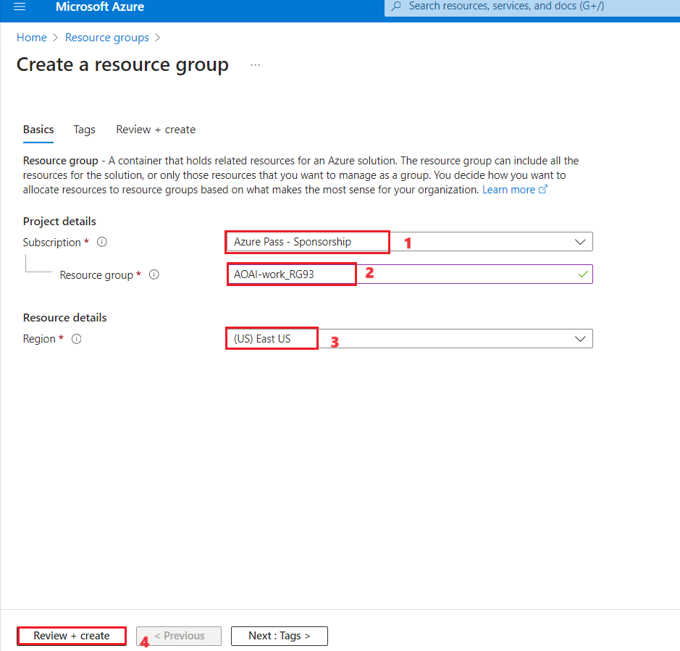

1. In the **Review+create** tab, once the Validation is Passed, click on the **Create** button.

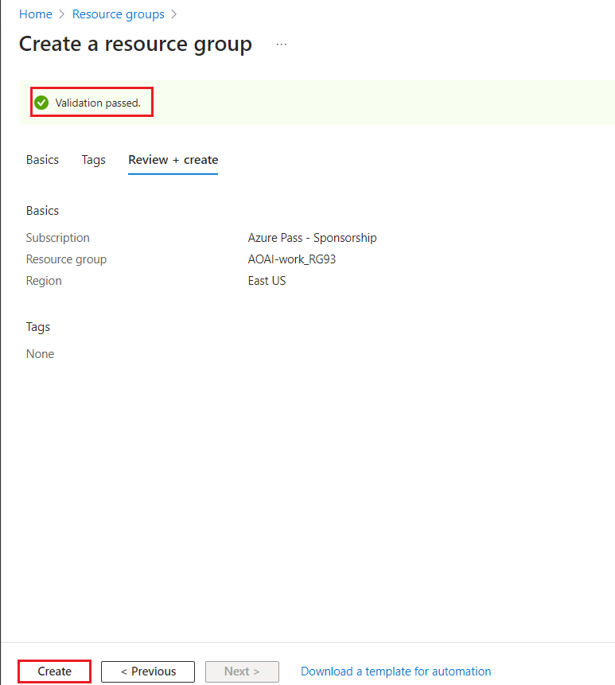

1. Wait for the deployment to complete.

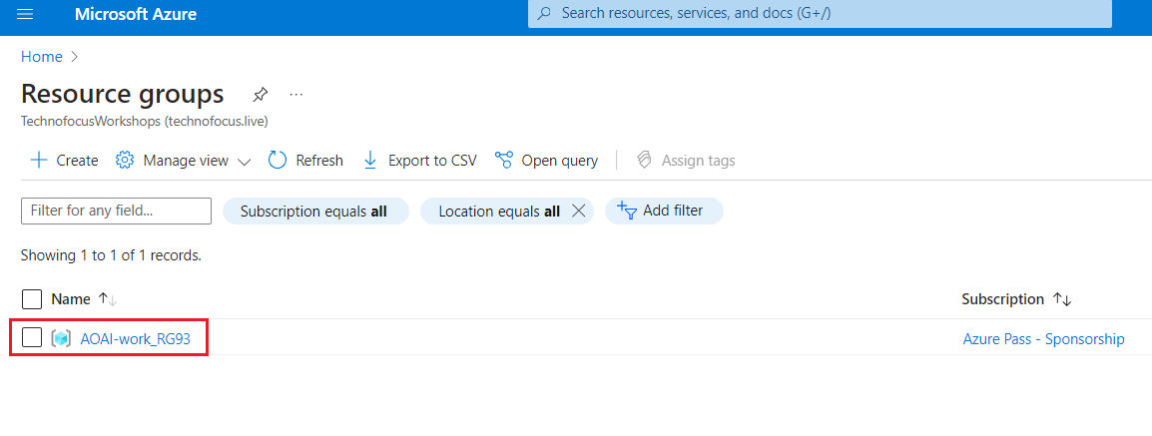

## **Task 6: Deploy Azure services needed for the application**

1. In your Windows search box, type +++Docker+++ , then click on **Docker Desktop**.

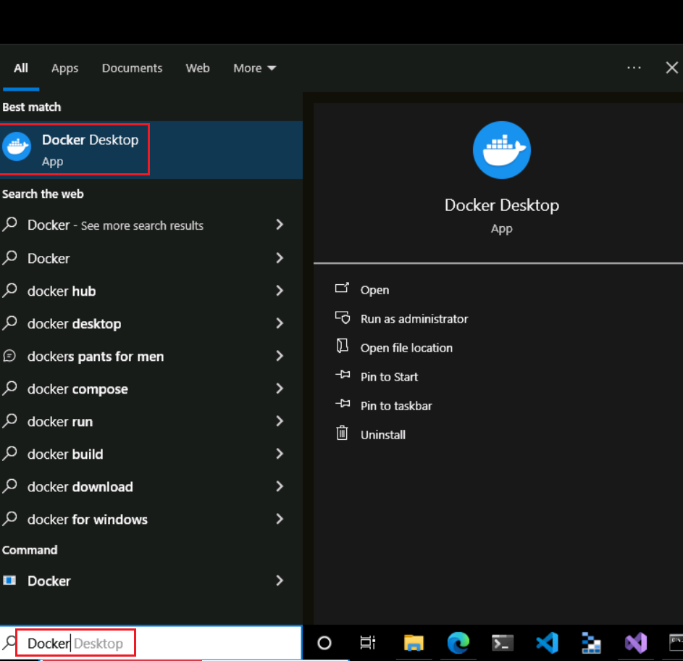

1. The **Docker Desktop** gets opened..

1. In Windows explorer go to +++ C:\Labfiles\Real-time-Payment-Transaction-Processing-at-Scale\infrastructure\AKS-Construction\bicep **+++** and open **main.bicep** file

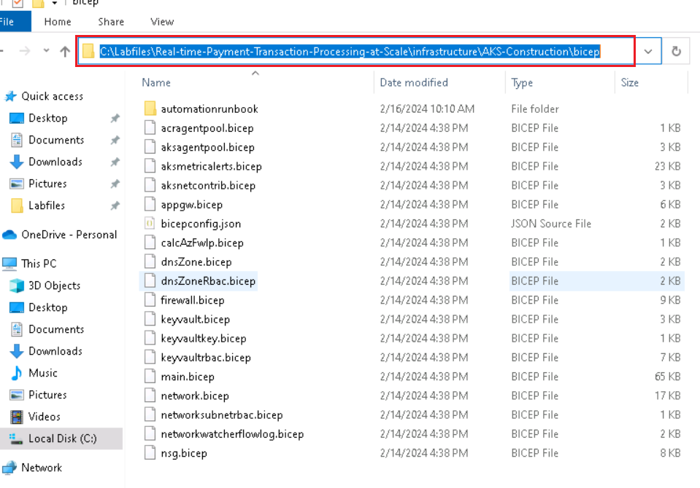

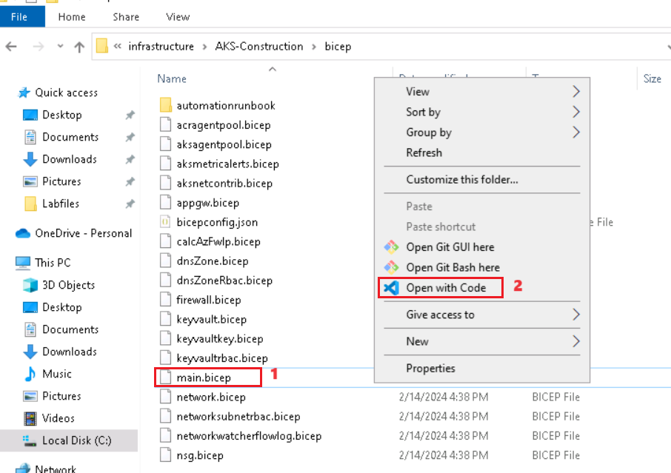

1. In line no:854, update **aksLastVersion** from “**1.26.6**” to **+++1.28.3+++** and **save** the file.

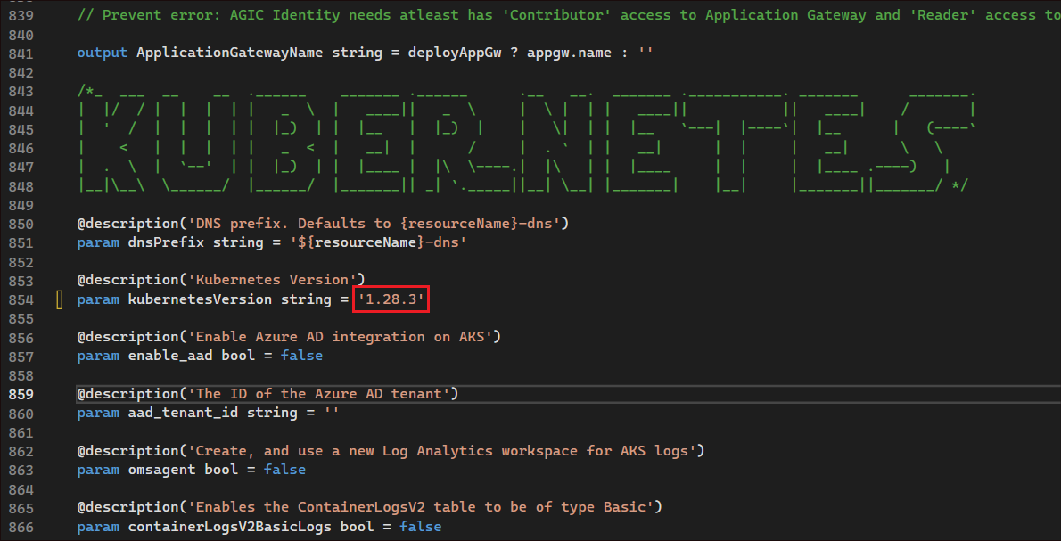

1. Click on **Start** and type +++**powershell+++** in the search bar and select **Run as administrator** under **Windows PowerShell**.

1. Click on **Yes**.

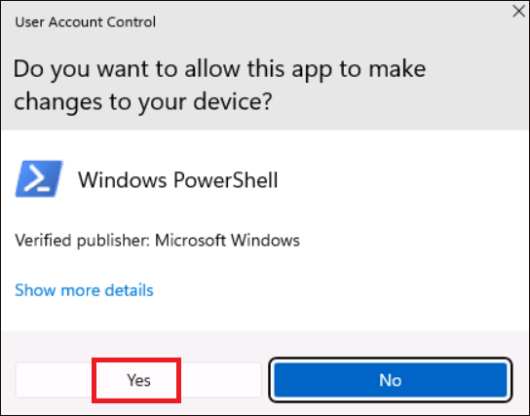

1. Run the below command to set the policy to **Unrestricted** and enter **A** when asked to change the execution policy.

**+++Set-ExecutionPolicy Unrestricted+++**

1. Change the current directory to the **Labfiles** directory and navigate into the project cd .\**Real-time-Payment-Transaction-Processing-at-Scale** folder by running the below commands.

**+++cd\+++**

**+++cd Labfiles+++**

**+++cd .\Real-time-Payment-Transaction-Processing-at-Scale+++**

1. Run the PowerShell script in the next step to provision the infrastructure and deploy the API and front end. Provide the name of the resource group that you have created. This will provision all of the required infrastructure, deploy the API and web app services into Azure Kubernetes Service (AKS) if using the deploy Aks flag below or Azure Container Apps (ACA), and import data into Cosmos DB.
2. Replace **RG_NAME** with the Resource group name that you created in Task 2 - +++**AOAI-work_RG**+++XX. Replace the **Subscription ID** with your subscription id, that you noted down in Task 1.

**++./deploy/powershell/Unified-Deploy.ps1 -resourceGroup <RG_NAME> -subscription <Subscription ID> -locations 'EastUS,WestUS' -deployAks $true++**

**Note:** Copy the above command to a notepad, replace the placeholders with your values and then paste the command in the **PowerShell**.

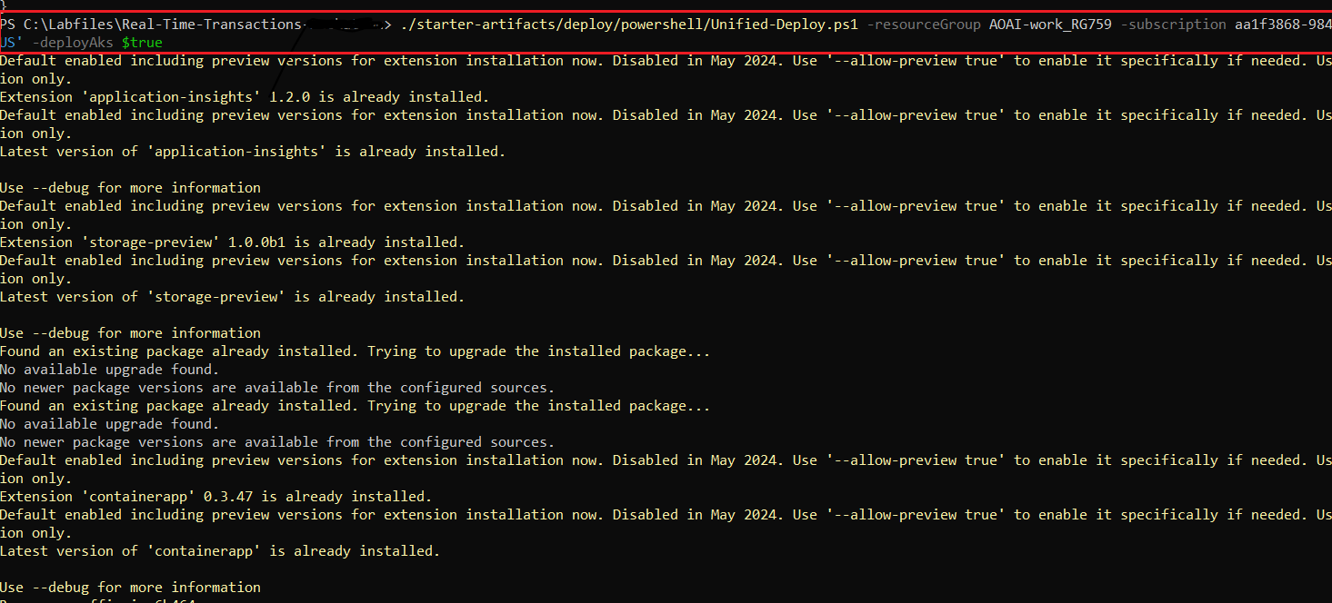

1. Select your Azure credentials when prompted.

1. Switch back to PowerShell window, you should see subscription details.

1. Wait for the ARM template to create Azure OpenAI and gpt-35 turbo model deployment .

**Important****:**

Please refer to the **Appendix** that is available at the end of this lab, to check for the troubleshooting steps if you face any issue with the deployment..

1. It also creates the CosmosDB and App Insights.

1. Then, it uses the docker compose to build and tag images.

1. Look for the **Status: deployed** message.

1. The files are then transferred, and the **website Uri** is displayed. Copy the **URL** and paste it into a browser.

1. You should be able to access the application as in the screenshot below.

## **Task 7: Verify deployed resources in the Azure portal**

1. Open a browser go to +++**https://portal.azure.com**+++ and sign in with your Azure login credentials (from the **Resources** tab).On the Home page, click on **Resource Groups**.

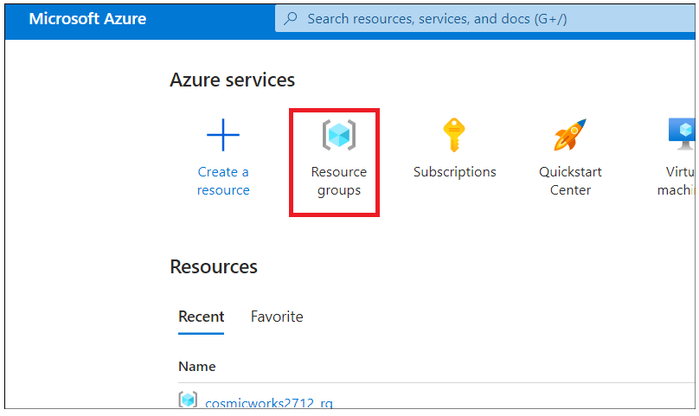

1. Click on your resource group name **AOAI-work_RGXXX**

1. Make sure the below resource got deployed successfully into two regions i.e East US and West US.
   * Application insights
   * Azure Container Apps (or AKS)
   * Container Registry
   * Azure Storage
   * Azure Networking

The below resources get deployed in East US alone

* + Azure Cosmos DB
  + Azure OpenAI Service
  + Storage account

FrontDoor and CDN profile and certain other resources that are deployed globally.

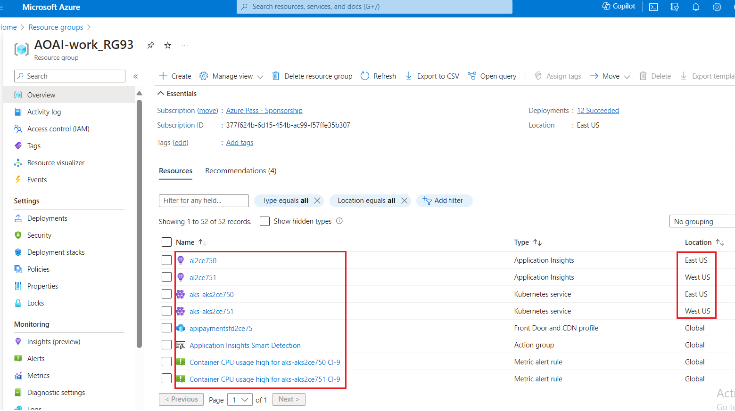

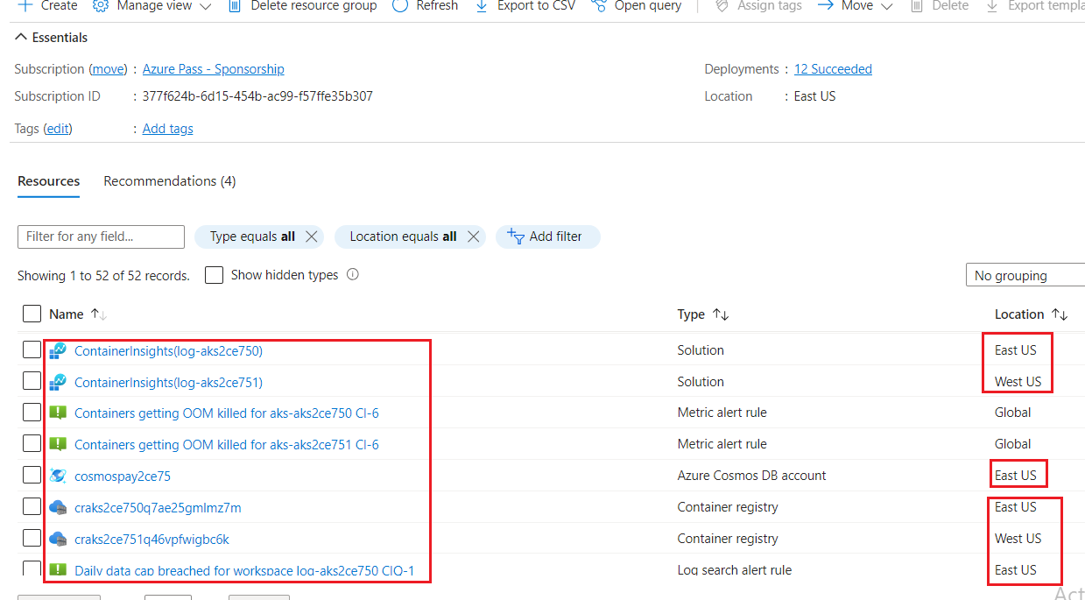

1. Make sure **Azure OpenAI** resource and **Storage account** are deployed in **East US** region successfully.

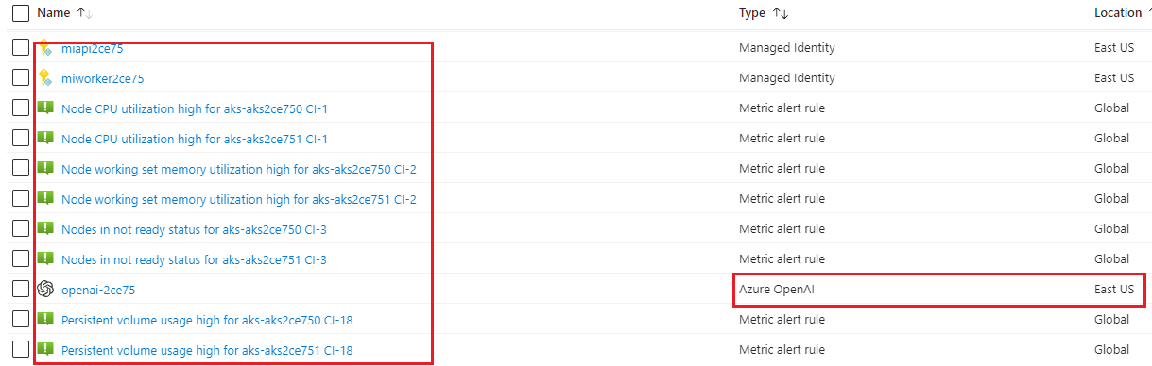

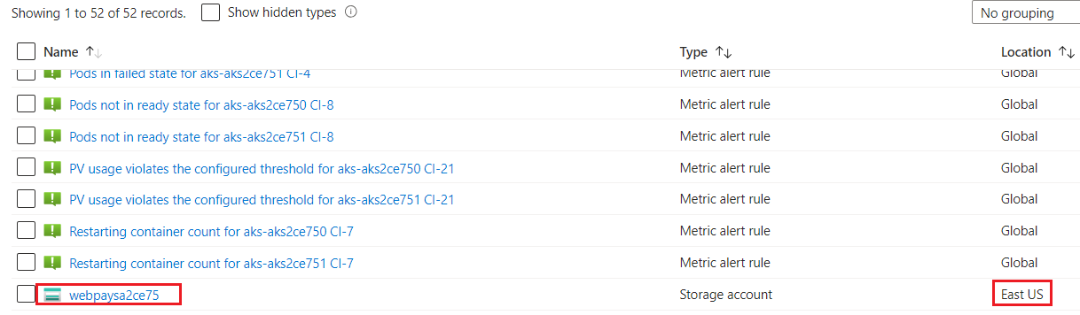

1. Click on the **Azure Cosmos DB** account name.

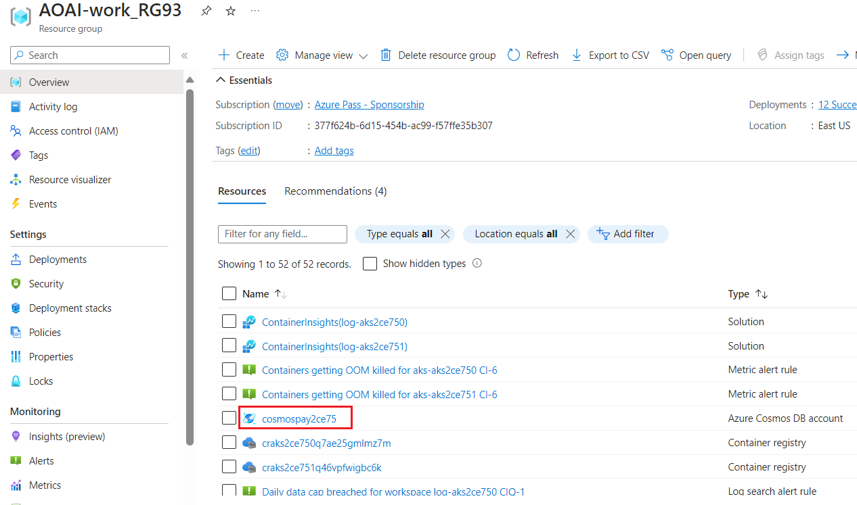

1. Click on **Replicate data globally** from the left navigation menu.

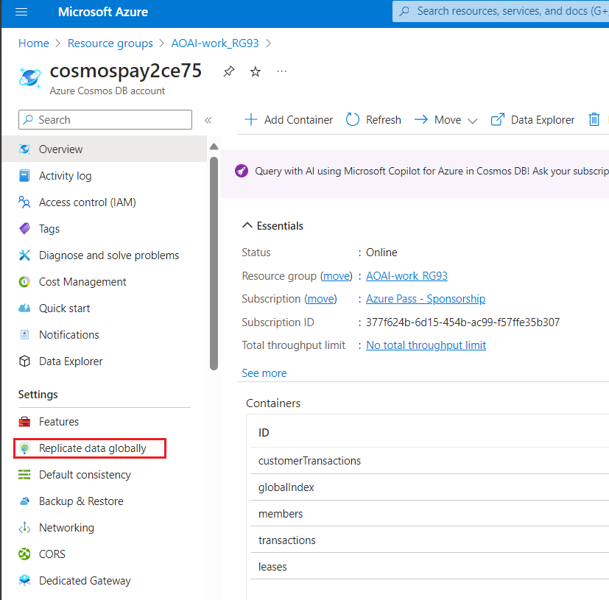

1. Make sure that East US is the Read/Write and West US is the Read only region.

.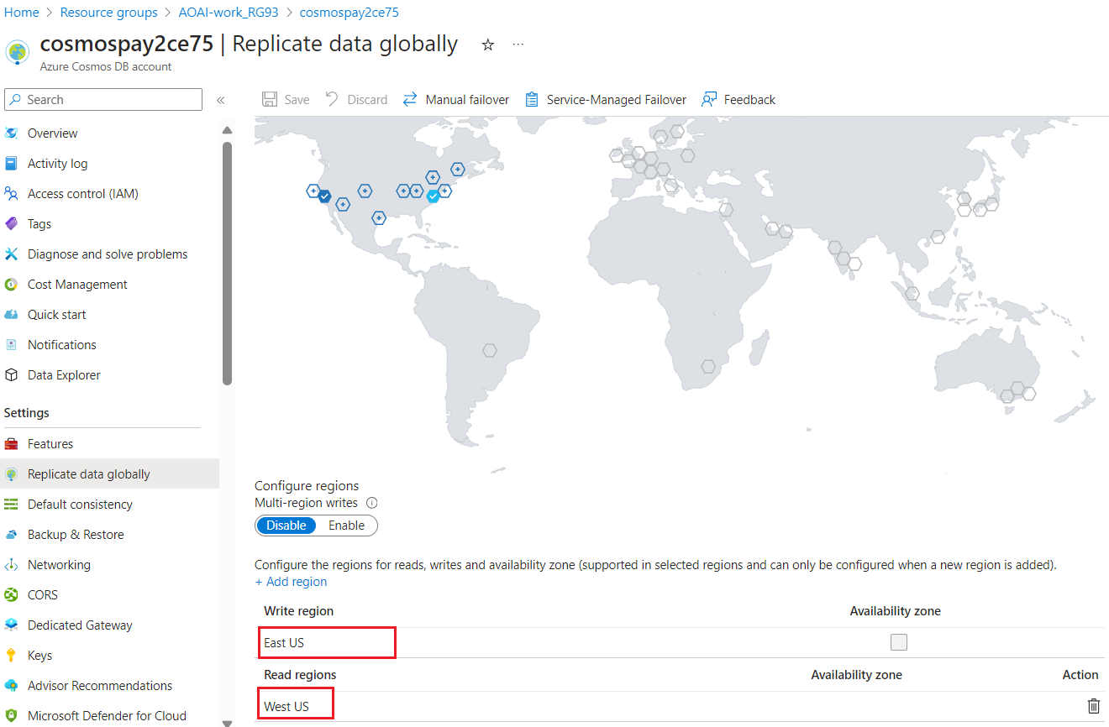

1. Click on **Keys** from the left navigation menu and browse through the **URI, Primary Key** and **Primary connection string** values to a notepad

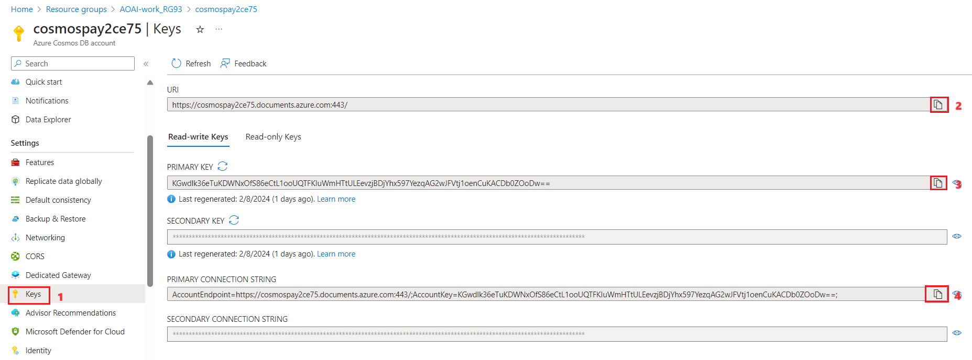

1. Click on **Data Explorer** and check that the **database** and **containers** got created.

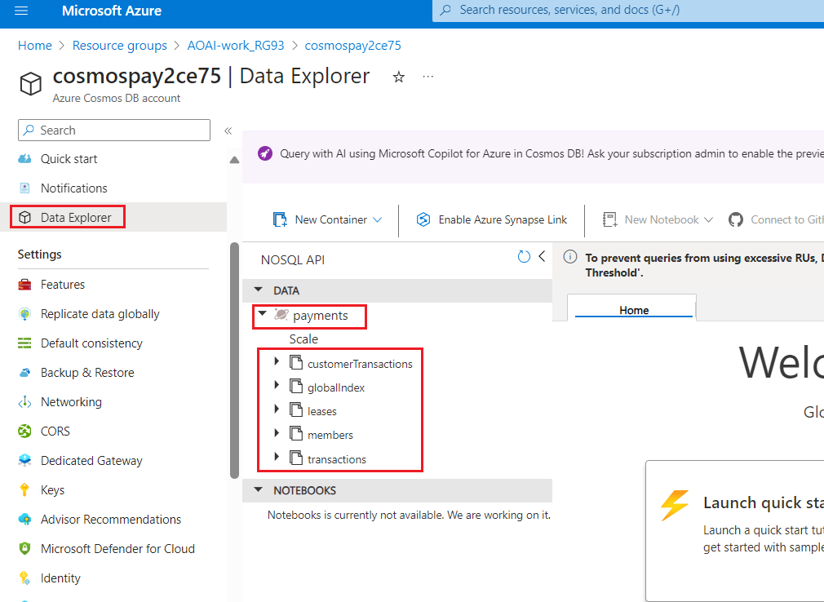

1. Go back to the resource group by clicking on resource group from the top navigation menu.

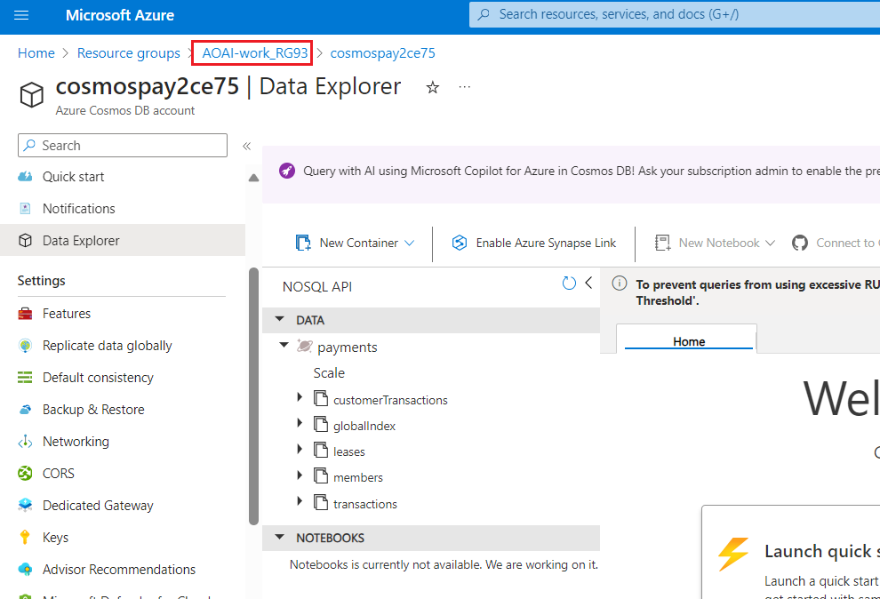

1. On the resource group, click on the **Azure OpenAI** resource.

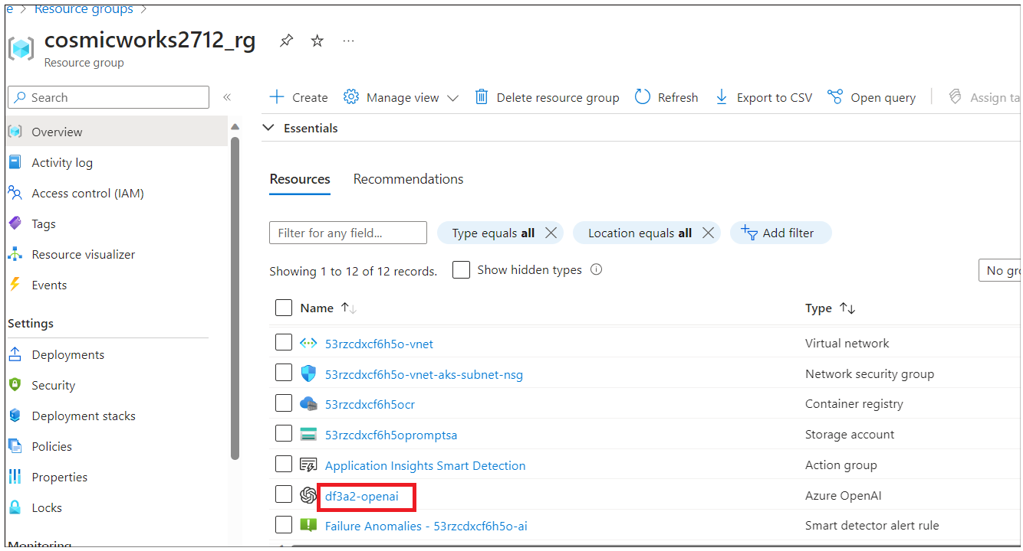

1. Click on **Keys and Endpoints** from the left navigation menu and observe the **Endpoint** and the **KEY** values.

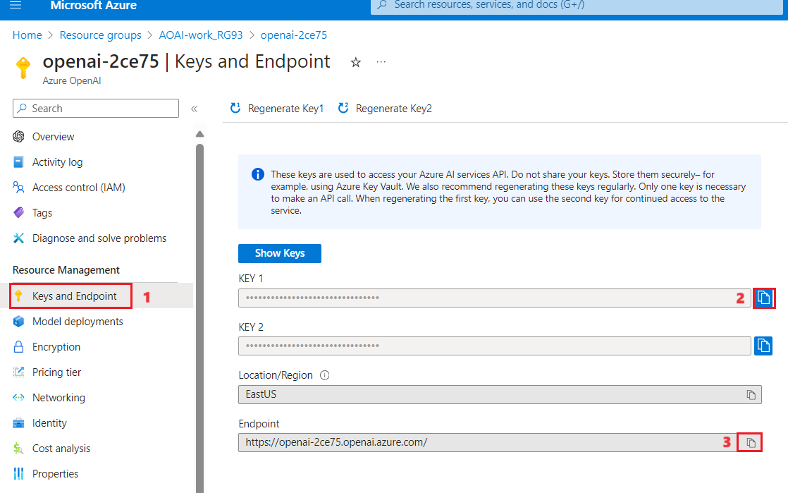

1. On the **Azure OpenAI** resource window, click on **Overview** in the left navigation menu, then under the **Get Started** tab, click on the **Go to Azure OpenAI Studio** button to open **Azure OpenAI Studio** in a new browser.

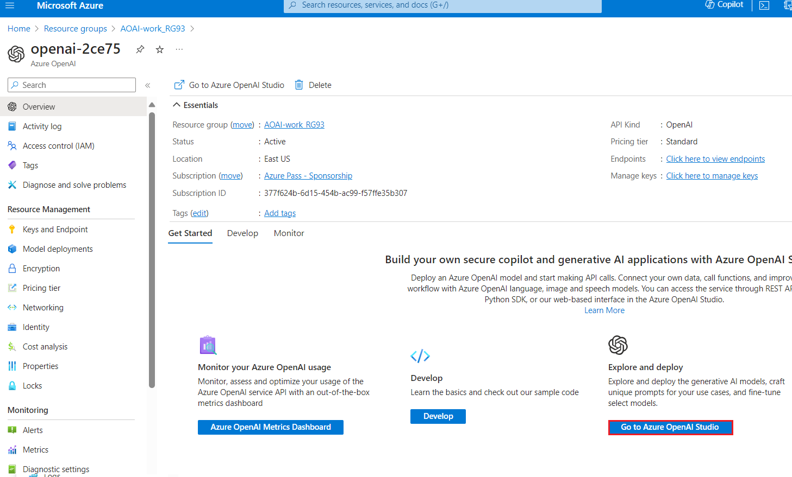

1. Make sure **gpt-35-turbo** should be deployed successfully by selecting **Deployments** from the left navigation menu.

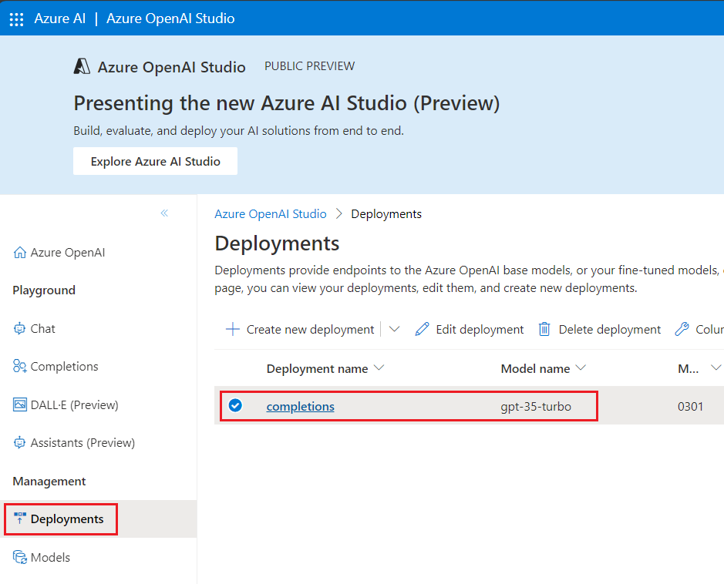

1. Go back to the resource group page and click on **the Storage account** name.

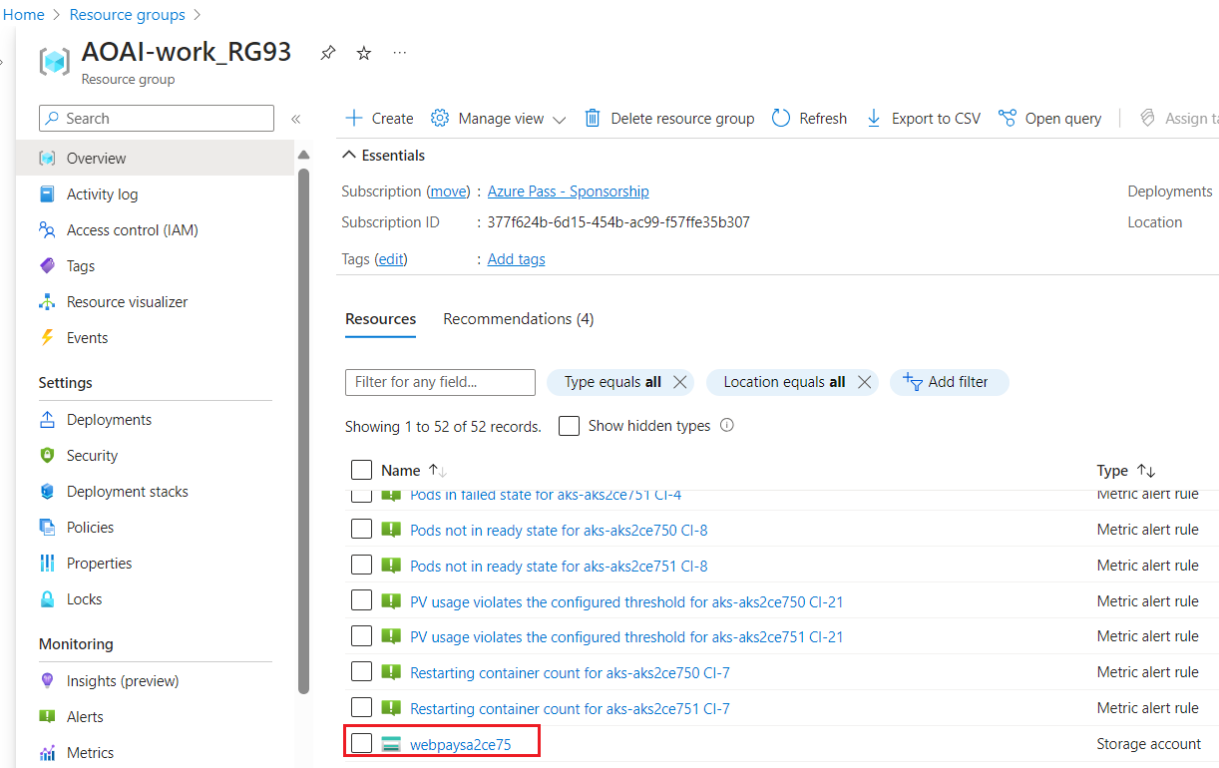

1. From the left navigation menu, click on **Access keys.** Observe the **Connection string** value and the **Key** to the notepad.

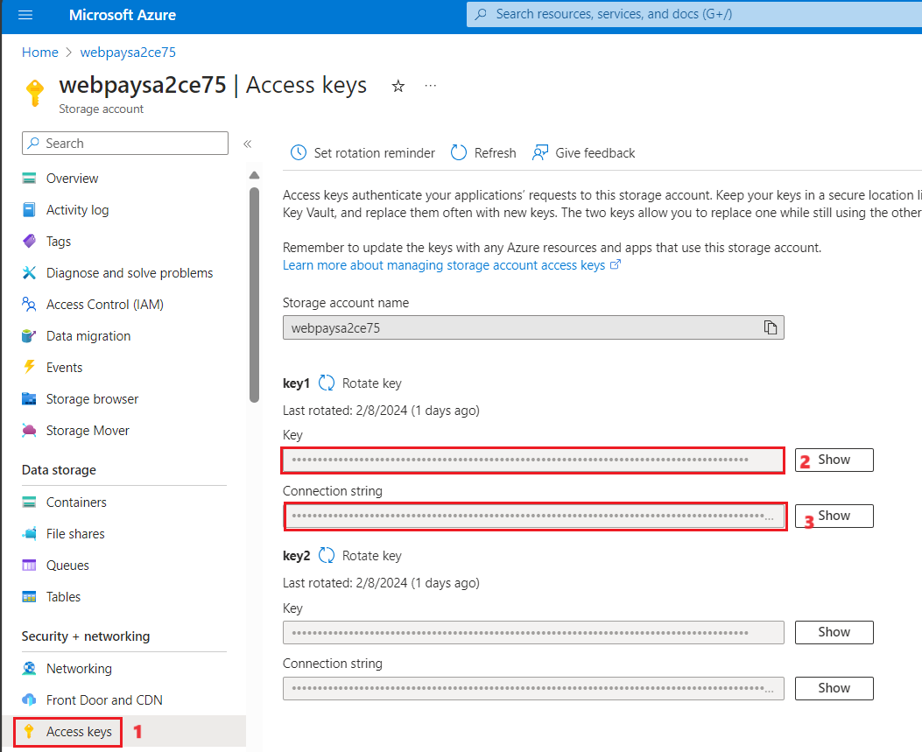

1. From the left navigation menu, click on **Static website,** copy the **Primary endpoint URL** and save it in notepad

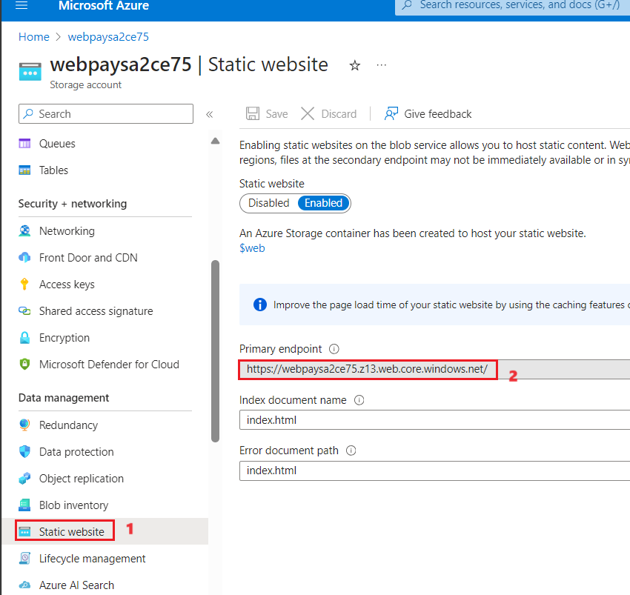

## Appendix

1. If the **aks** **resource** does not get created and there is a prompt to enter the **login** credentials for **Docker** in the Powershell, check if the **steps 3 and 4** of the **Task 3** where in the **latest Kubernetes version** needs to be updated has been performed successfully.
2. If you get the issue of the **subdomain not available**, as in the below screenshot, you need to delete the existing Resource group and execute the deployment command again to redeploy.

* Enter **Ctrl+C** in the PowerShell window to stop the execution.
* From the Azure portal, delete the Resource group.
* In the PowerShell, navigate back to the **Realtime payment processing at scale** folder(You will now be in the deploy/powershell folder inside the Payment processing. So, execute +++**cd..**+++ twice and navigate to the mentioned folder).
* Execute the deployment script(Step 10) again from the PowerShell.

1. If the deployment does not get completed successfully, from the Resource group page, select **Deployments** from the left navigation pane and check the status of the resources. If the **AKS clusters** are created, but the **deployment** of the AKS resources **fail**, then you will have to execute the below commands, replacing the placeholders for the

• **Your AKS Cluster 1/2**

• **Your Resource group**

• **Your Subscription id**

with your resource names.

**az resource update --name <Your AKS Cluster 1> --namespace Microsoft.ContainerService --resource-group <Your Resource group name> --resource-type ManagedClusters --subscription <Your Subscription ID>**

**az resource update --name < Your AKS Cluster 2> --namespace Microsoft.ContainerService --resource-group <Your Resource group name> --resource-type ManagedClusters --subscription <Your Subscription ID>**

Execute the deployment command **(Step 10)** to deploy the resources again.

1. If you get an error message stating that **Container registry not found** and Docker login credentials is prompted, perform the below steps.

* Do a **Ctrl+C** to stop the execution.
* Navigate back to the **Realtime payment processing at scale** folder(You will now be in the deploy/powershell folder inside the Payment processing. So, execute +++**cd..**+++ twice and navigate to the mentioned folder) and then execute the below commands.

+++az login+++

* Login with your Azure login credentials.
* Replace the place holder with the container registry name that is getting listed in the error and execute the below command.

+++az acr update -n <**Container registry name**> --admin-enabled true+++

* Execute the deployment command **(Step 10)** to deploy the resources again.

1. If there is an error that says **npm EIDLETIMEOUT** as in the screenshot below, execute the below command.

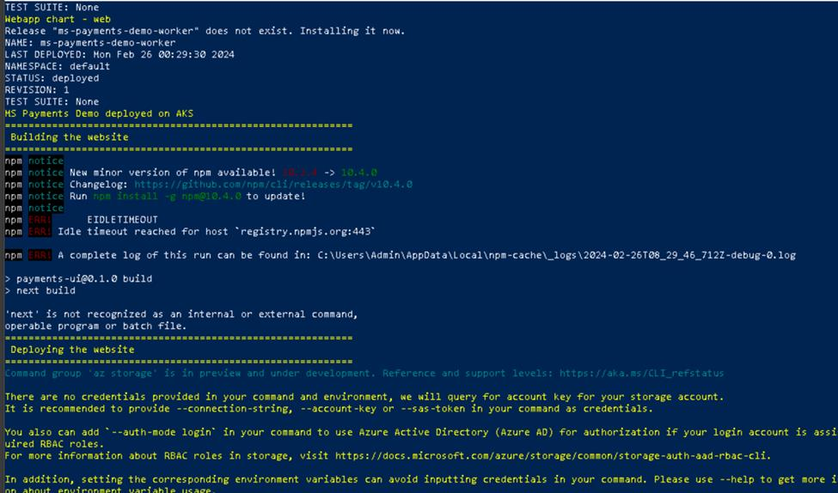

./deploy/powershell/publish-Site.ps1

Enter the **Resourcename** and **storageaccount** name (that will be there under the created resources in the Azure portal) when prompted.

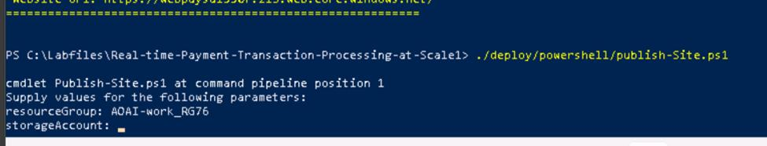

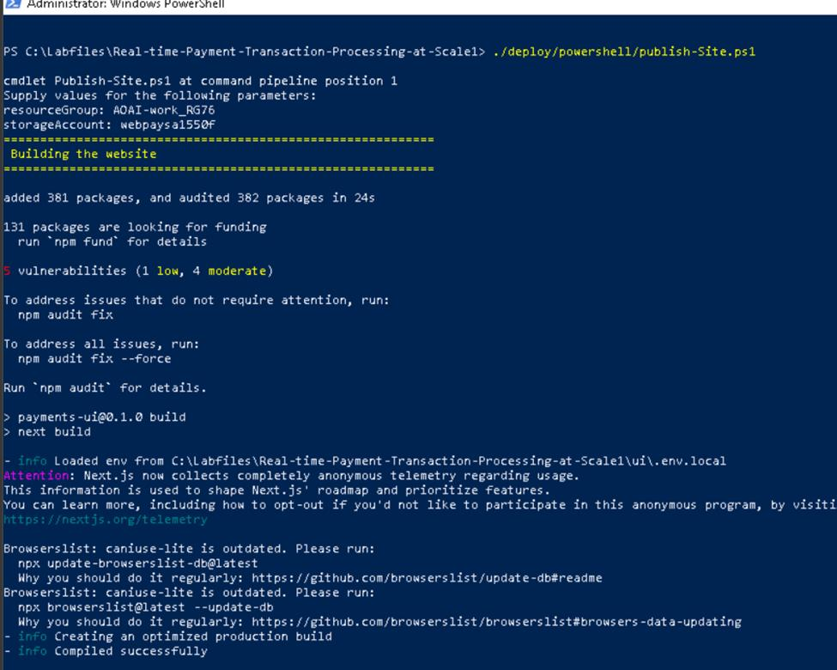

1. If you get an **insufficient Quota** issue on the AOAI service creation, it will be due to the fact that you would have deleted an already created one. To resolve this, follow the below steps and then restart the deployment,.
   * From the Azure portal home page, search for +++**Azure AI Services**+++ and select it.

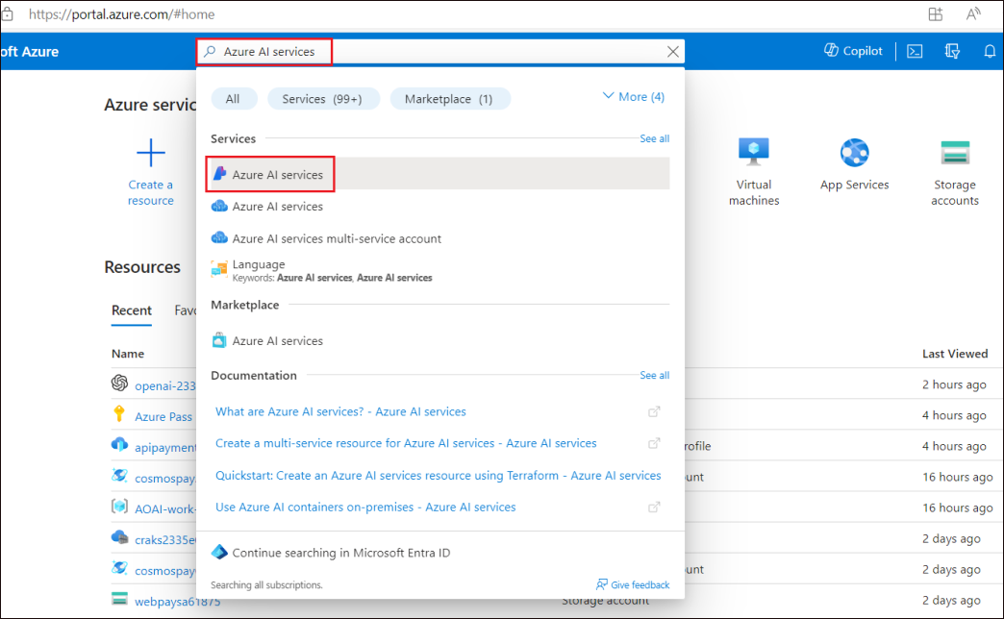

* + On the **Azure AI Services page**, select **Azure OpenAI** from the left pane.

* + Select **Managed deleted resources**.

* + Select the AOAI resource that is listed, and click on **Purge**.

* + Click on **Yes**.

* + This will release the quota and the resources withheld by the deployment.
  + Once you do not see any resources under the Managed deleted resources,

* Execute the deployment command **(Step 10)** to deploy the resources again.